How to Login to Clever on your laptops:

- Log in to your computer with your regular username and password

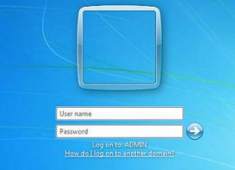

- Once you log in, your Novell Zenworks Applications window should pop up. Click on the Clever icon. It will get you to the Clever log in page. If you do not see that in your Zenworks applicaiton window you can open up Chrome and type in https://clever.com/in/u46

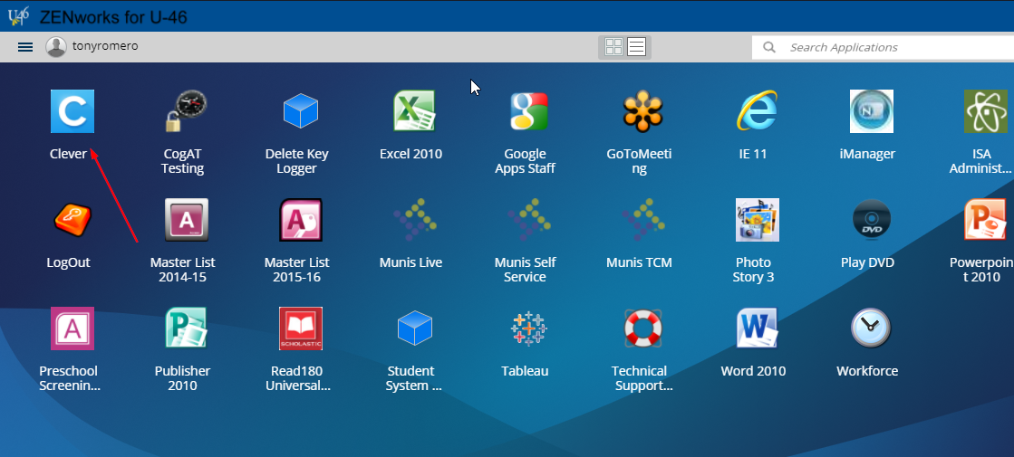

- When you get to the clever log on page click on the Log in with Google button

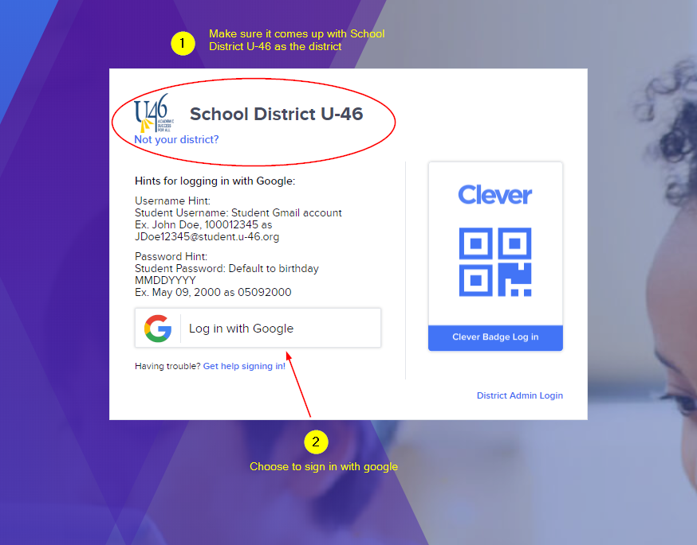

- You will see the portal screen below once you are successfully logged into Clever.

